SESSION 11 ASSIGNMENT

- Pie Chart
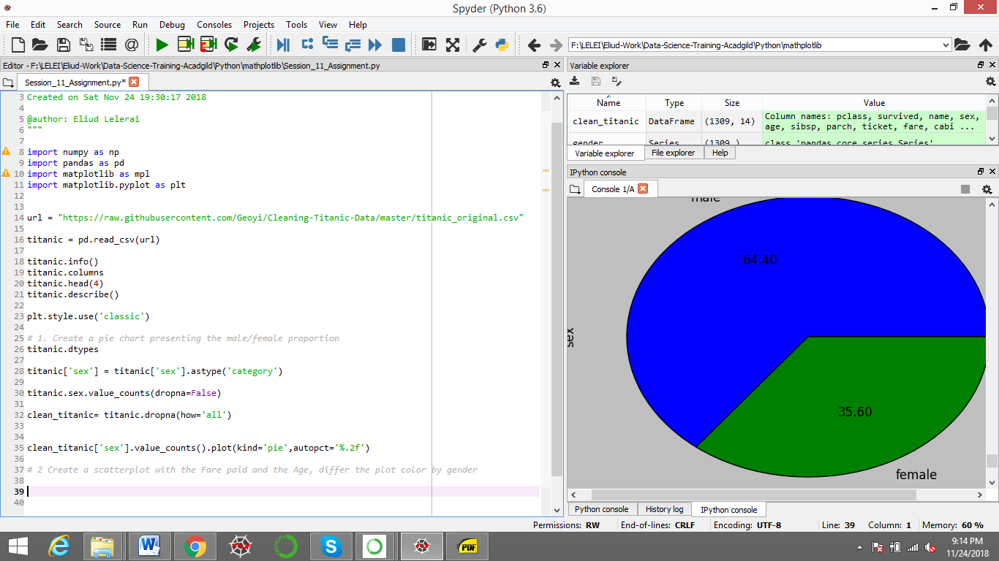

- Scatter Plot

